1. Find the domain of the function using interval notation.

[ f(x)= \frac{ \sqrt{x-6} }{ \sqrt{x-4} ](https://my.uopeople.edu/filter/tex/displaytex.php?texexp=%20f(x)%3D%20\frac%7b%20\sqrt%7bx-6%7d%20%7d%7b%20\sqrt%7bx-4%7d%20)

**Solution:**

The domain is the set of all possible input values (in this case, values of **x**) for which the function is defined. The square root function is defined only for non-negative values. So, the expressions inside the square roots (***x*−6** and ***x*−4**) must be greater than or equal to zero. So,

**x-6 ≥ 0** and **x-4 > 4**

**Solve for x:  
x-6 ≥ 0**

**x ≥** **6**

**Now consider denominator:  
x-4 > 4**

**x > 4**

**so,  
x ≥ 6 and x > 4**

Combine the conditions and express the domain in interval notation. Since ***x*** must be greater than or equal to 6 and greater than 4, the domain is:  
**x ɛ [6, ∞)**

This means that the function is defined for all real numbers ***x*** greater than or equal to **6**.

2. Sketch a graph of a piecewise function. Write the domain in interval notation.

[ y=x^2 ](https://my.uopeople.edu/filter/tex/displaytex.php?texexp=%20y%3Dx%5e2%20) for {-1 \leq x \leq 1} and y = 3x - 2 {1 \leq x \leq 3}

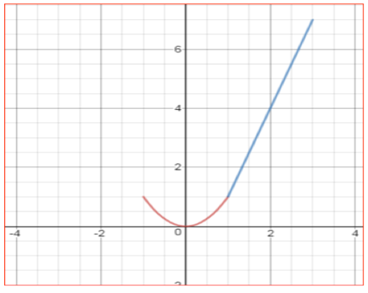

**Solution:**

**y = x2** where values of x between -1 to 1 including 1 and -1

**y = 2x+1** where values of x between 1 to 3 including 1 and 3

Domain in Interval notation:

For the first piece, the domain is **[-1, 1]**

For the second piece, the domain is **[0, 3]  
Overall domain of Piecewise function:**

**[-1, 1]∪[0, 3]**

**Graph:**



The Red curve show the piecewise function **y = x2** and blue curve shows **y = 2x + 1**.

3.

The cost in dollars of making x items is given by the function *C*(x) = 10x + 500.

1. The fixed cost is determined when zero items are produced. Find the fixed cost for this item.

**Solution:**

Given functions: **C(x) = 10x + 500**

Put **x = 0**, when **0** items are produced

**C(0) = 10(0) + 500**

**C(0) = 500,**

**So fixed cost is 500**

1. What is the cost of making 25 items?

**Solution:**

Given functions: **C(x) = 10x + 500**

Put **x = 25**, when **25** items are produced

**C(25) = 10(25) + 500**

**C(25) = 750,**

**So fixed cost for making 25 items is 750**

c. Suppose the maximum cost allowed is $1500. What are the domain and range of the cost function, *C*(x)?

**Solution:**

The domain of the cost function is the set of all possible values of ***x***. Since ***x*** represents the number of items produced, it must be a non-negative quantity. So, the domain is ***x* ≥ 0**.

To find the range, we consider the maximum cost allowed, which is **1500**. Set ***C*(*x*)** equal to **1500** and solve for ***x***:

Given functions: **C(x) = 10x + 500**

Put **C(x) = 1500**,

**10(x) + 500 = 1500**

**10(x) = 1500 – 500**

**10(x) = 1000**

**x = 1000/10**

**x = 100**

**So, when the cost is 1500, it corresponds to *x*=100 items produced**

**Domain: *x*≥0**

**Range: *C*(*x*)≥500**